Data Audit Report
Employee attrition dataset · CortexHR AI/ML · Task 1
Prepared for the AI/ML team · 15 October 2026 · Source: sheet attrition_dataset
Bottom line
The data is good enough to model, but not as delivered. It contains 6 duplicate rows, a handful of impossible values, 3 mistyped salaries and six columns that give away the answer. Left in, they would make any model look brilliant in testing and fail in real use.
Every problem below has a written decision, except two that only the Python team can answer: those are recorded as open items (section 8) and have not been assumed or silently corrected. The decisions become the rules of the reusable pipeline in Task 2.

2,389 × 42  rows × columns | 14.6%  left within 12 months | 6  duplicate rows | 6  columns that leak the answer | 3  salaries with an extra zero

1. What we looked at
Each row is one employee snapshot (pay, tenure, raises, engagement, attendance …) plus the answer to predict: did this person leave within 12 months? It mixes 383 real employees (30 Sep 2025), 2,000 simulated historical rows (2021–2025) and 6 duplicates. Dictionary: docs/data_dictionary.md.

2. Missing values
Eleven columns have blanks. Most are not mistakes: a blank usually means “this does not apply to this person”. The cause decides the fix.
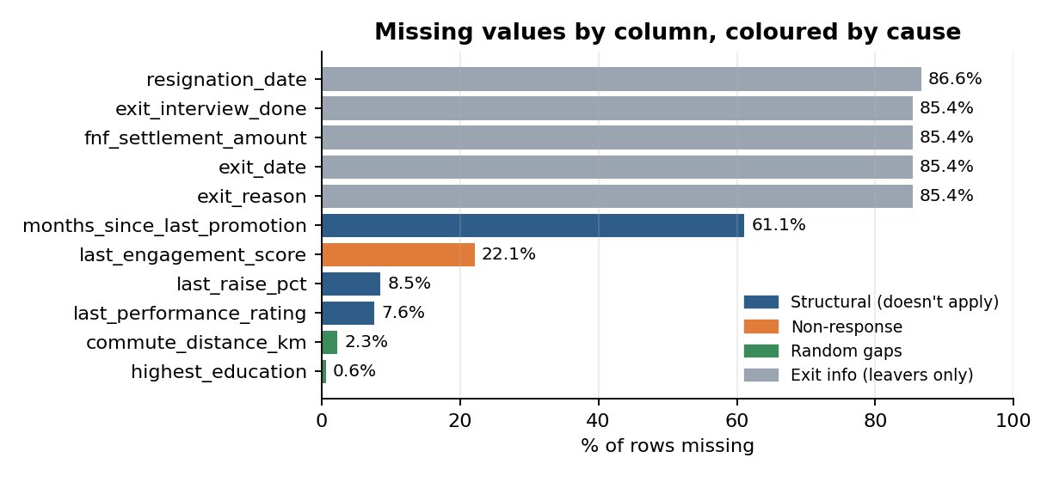
Figure 1. Share of blank cells per column, coloured by the reason for the blank.
- Never happened (blank means “none”): never promoted (61.1%), never had a raise (8.5%), no appraisal yet because they joined under 12 months ago (7.6%).
- No survey answer (22.1%): non-responders leave slightly more often (16.7% vs 14.0%), but the gap could be chance (p = 0.148).
- Random gaps: commute distance (55 rows) and education (15 rows).
- Exit columns are blank for everyone who stayed. That is not missing data; it is leakage (section 6).
Decision: keep every real column; fill blanks with a neutral value (0, tenure, median or “Unknown”, learned from training data only) and add a “was missing” flag where the blank carries meaning.
Our answer: a column is 40% missing. Drop, fill or flag?
Ask why first, not how much. If the blank means something (“never promoted”), keep the column, fill it and add a “was missing” flag. Filling alone hides that the value never existed; dropping throws the signal away.
Drop only if the column is mostly blank and the blanks mean nothing and it adds no signal, or if it leaks the answer. Here, months_since_last_promotion is 61.1% blank, more than 40%, and it stays.

3. Impossible and inconsistent values
These are values that cannot be true, which is different from being unusual. We wrote simple rules from the data dictionary and counted violations.
Problem | Rows | Decision
Exact duplicate rows (same employee twice) | 6 | Drop the second copy; split data by employee so a person is never in both train and test
Negative tenure (observation before join date) | 4 | On hold (open item O1). Raw value kept and flagged; not corrected until the Python team confirms the join dates
Attendance above 100% (1.12) | 2 | Cap at 100%
Same city spelled differently (Bangalore / Bengaluru, Madras / Chennai, Delhi-NCR …) | 13 | Map to one spelling (16 labels become 9 cities)
Work-from-home share below 0% or above 100% | 213 | Clip to 0–100% (tiny noise)
Total experience smaller than time at this company | 137 | Raise to tenure in years
The last two problems are not on any obvious checklist and appear only in the simulated rows, which suggests the two data sources were generated by slightly different logic.

4. Outliers: two methods compared
All outlier statistics below use the 2,383-row deduplicated dataset (dropping the 6 duplicate rows so employee distributions are not distorted). IQR rule: flag values far outside the middle 50% of people. z-score: flag values more than 3 standard deviations from the average. IQR flagged 1.6–7× more rows (salary 93 vs 26, hours 48 vs 15, tenure 73 vs 45). These columns are skewed: a few huge values stretch the average and make z-score more tolerant. Neither test can tell an error from a rare but real value, so we added a business check: pay ÷ comp-ratio must match the role’s mid-point.
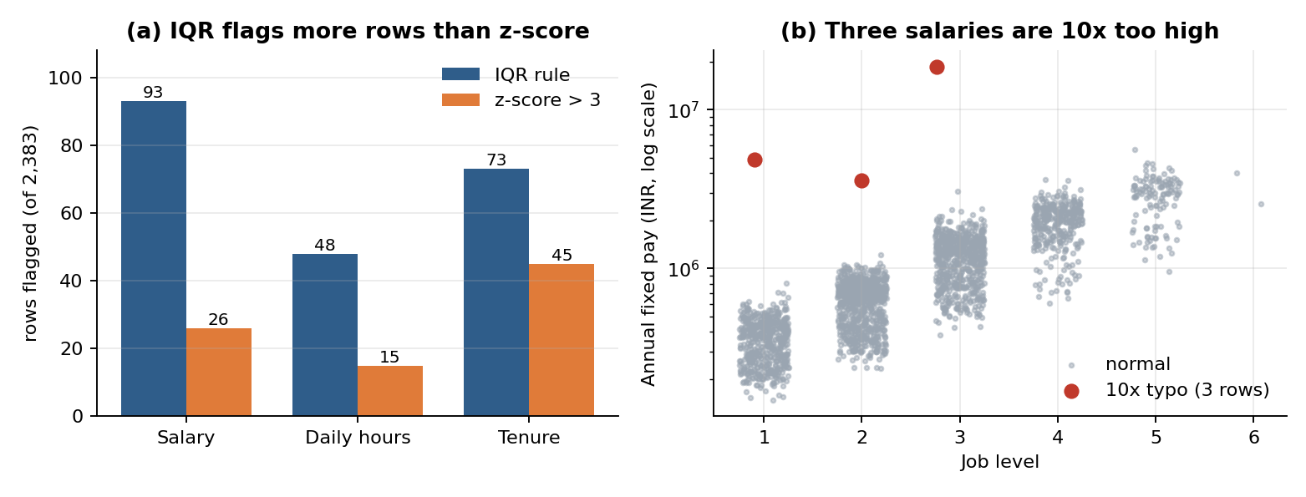
Figure 2. (a) Rows flagged by each method. (b) The business check isolates exactly three salaries that are 10× too high.
- Salary: 3 mistyped salaries (EMP-0034, EMP-0433, EMP-0601); dividing by 10 puts each in line with its job level. The other high salaries are genuine senior staff.
- Hours: one person (EMP-0313) averages 1.8 h/day with 20% attendance. The two figures agree, so it looks like a real long absence.
- Tenure: up to 13.7 years is real; only the 4 negative values are errors. Overtime: 81% of people have none, so IQR flags anyone with any overtime (445 rows), which is normal behaviour.
Decision: correct the 3 typos (÷10); keep genuine extremes; flag EMP-0313 for HR; log-transform pay and overtime for linear models.

5. Class imbalance
14.6% of people left (349 of 2,383); 85.4% stayed, about six stayers for every leaver. A model that always says “nobody leaves” would be 85.4% accurate while finding no one, so accuracy is a misleading score here. The rate is stable across years (13.5–16.3%). Customer Support is highest (21.1%); Legal is lowest (6.5%, but only 62 rows, so treat small departments with caution).
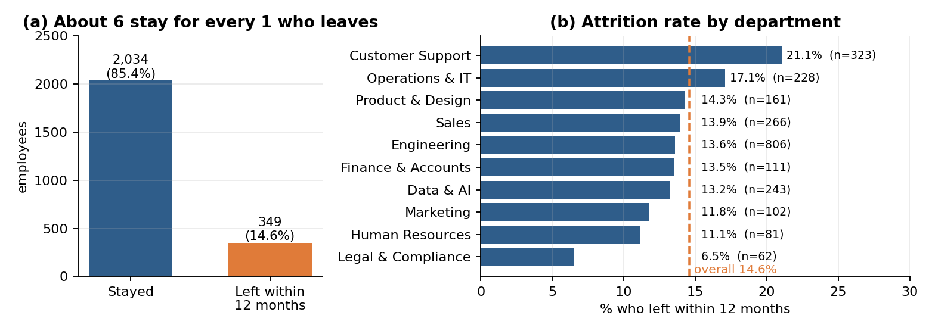
Figure 3. (a) Stayed vs left. (b) Attrition rate by department.
Decision: keep the data as is; stratified splits; judge with ROC-AUC, PR-AUC, precision and recall (never accuracy alone); start with class weights.

6. Data leakage
Leakage means the model sees information during training that will not exist when it must make a real prediction. The prediction moment is 30 Sep 2025; anything created after it, or derived from the answer, is a leak.
 | 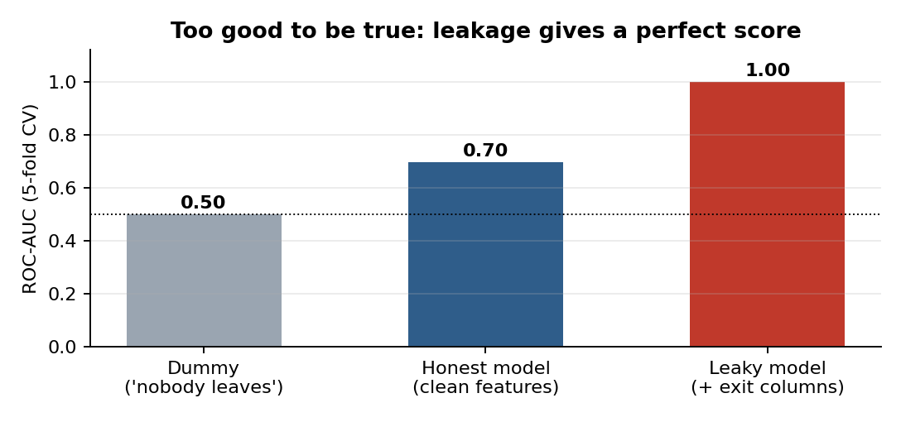  Figure 4. Same model, with and without the exit columns.
  Leaking column | Why it leaks
  exit_date | Exists only for leavers
  exit_reason | Recorded at the exit
  exit_interview_done | Held at the exit
  fnf_settlement_amount | Paid at the exit
  resignation_date | Exists only for resigners
  voluntary_left_within_12m | A sub-label of the answer itself
Proof: adding the exit columns to an ordinary model lifts ROC-AUC from 0.70 to 1.00. The best honest single column (engagement) reaches only 0.61; a near-perfect score is a warning.
- Other sheets run past the snapshot date: 21% of survey rows, 21% of appraisals and 68% of attendance months are dated after 30 Sep 2025. Cut features off at the observation date.
- Not features: row_id, employee_id (grouping only), source, observation_date (time splits only). Gender and age sit in a separate sheet and stay out of the model; use them only to test fairness.
- Not yet confirmed: dept_attrition_rate_prior_12m is documented as backward-looking but has not been verified (open item O2).
Decision: drop the six leaking columns before any modelling and add a check that fails if any of them reaches the feature table.

7. Decision list for Task 2 (full 24-row log: docs/decisions.md)
ID | Issue | Decision
D01 | Duplicate rows (6) | Drop second copy; split by employee_id
D02, D04–D06 | Spelling, attendance > 100%, WFH share, experience < tenure | Standardise cities; cap attendance at 100%; clip shares to 0–100%; floor experience at tenure
D03, D24 | On hold: negative tenure; dept_attrition_rate_prior_12m | Open items O1 and O2. No assumption made; see section 8 for interim handling
D07–D10 | Salary typos; genuine outliers; EMP-0313; overtime | Divide 3 typos by 10; keep real extremes; flag EMP-0313; log-transform pay and overtime
D11–D16 | Blanks: structural, survey non-response, random gaps | Keep; fill (tenure, 0, median, “Unknown”); add “was missing” flag
D17 | Imbalance (14.6% leave) | Stratified splits; class weights; ROC-AUC, PR-AUC, recall
D18–D19 | Leaking exit columns and voluntary flag | Drop; assert they never reach the model
D20–D22 | Post-snapshot rows; identifiers; protected attributes | Cut off at observation_date; exclude IDs, source, gender and age from features
D23 | Fitting fill/scale rules | Learn them on the training split only (inside a pipeline)

8. Open items for the Python team
Only the people who built the data can answer these. Nothing has been assumed or silently corrected. Answers go here and in docs/open_items.md.
ID | Question and why it matters | What we did meanwhile | Team response
O1 | Negative tenure: confirm the correct joining dates for EMP-0248, EMP-0280, EMP-0568 and EMP-0596 (tenure −4, −5, −2, −1 months). No join dates exist elsewhere in the workbook, so any fix would be a guess. | Raw values kept and flagged; the 4 rows (0.2% of data) are left out of training until answered. | Pending
O2 | Possible leakage: confirm that dept_attrition_rate_prior_12m uses only exits before each row’s observation date. If it includes later exits it leaks the answer. Evidence so far: for real employees it is 0.7 points from the prior-12-month exit rate in the headcount sheet vs 10.8 points from the following 12 months. Consistent, not proof; the simulated rows were not tested. | Candidate feature only; models are trained and reported with and without it until answered. | Pending
O3 | (Extra, lower priority) Why do only the simulated rows have total experience below tenure (137 rows)? | Rule D06 applied; revisit if explained. | Pending
Cross-checks: ydata-profiling confirmed our blank and duplicate counts but flagged no impossible values, typos or label imbalance. All 98 of 98 problems in the workbook’s answer key are covered (the key was visible while exploring: validation, not a blind test).

